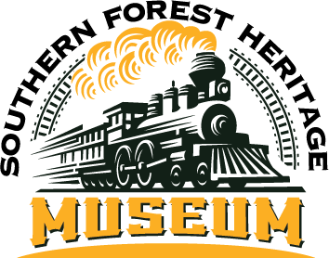

**SFHM FALL FESTIVAL 2023**

**OCTOBER 20 - 21**

77 Longleaf Road • Long Leaf, LA 71448 • Ph: 318-748-8404 • Fax: 318/748-8404

[director@forestheritagemuseum.org](mailto:director@forestheritagemuseum.org) OR linda@thegwmc.com

**FOOD BOOTH RESERVATION - $275 nonrefundable**

**\*FOOD VENDORS MUST CARRY AT LEAST $1,000,000.00 IN LIABILITY INSURANCE.**

**CERTIFICATES MUST BE PROVIDED.\***

BUSINESS/BOOTH NAME:_______________________________________________________________________

CONTACT NAME:______________________________________________________________________________

ADDRESS:____________________________________________________________________________________

____________________________________________________________________________________________

PHONE:___________________________EMAIL:_____________________________________________________

LIST FOOD/BEVERAGES BEING SOLD:

____________________________________________________________________________________________

____________________________________________________________________________________________

ELECTRICITY: NONE NUMBER OF BOOTH SPACES (10’X12’ EACH) ___________________________

TOTAL LENGTH OF TRAILER IF USED AS A BOOTH:____________________________________________________

AMOUNT OF PAYMENT ENCLOSED:_______________________________________________________________

I, the undersigned, do hereby acknowledge that neither the Southern Forestry Heritage Museum Fall Festival, its Board of Directors, the Rapides Parish Sheriff’s Office nor the village of Long Leaf is responsible for losses or damages to my merchandise or for personal injury to myself or any assigned workers during this festival.

_____________________________________________________ _______________________

NAME DATE

*The SFHM Fall Festival is operated by and proceeds benefit the museum and its site, a nonprofit organization.*