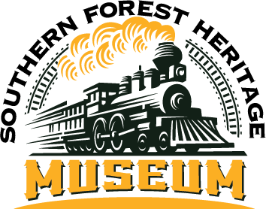

**SFHM FALL FESTIVAL 2025**

**OCTOBER 18th**

77 Longleaf Road • Long Leaf, LA 71448 • 318-748-8404

director@forestheritagemuseum OR linda@thegwmc.com

**RETAIL BOOTH RESERVATION - $25**

BUSINESS/BOOTH NAME:________________________________________________________________

CONTACT NAME:_______________________________________________________________________

ADDRESS:_____________________________________________________________________________

_____________________________________________________________________________________

PHONE:___________________________EMAIL:______________________________________________

MERCHANDISE BEING SOLD: ________________________________________________________________________________

_____________________________________________________________________________________

_____________________________________________________________________________________

ELECTRICITY: NONE NUMBER OF BOOTH SPACES (10’X12’ EACH) ____________________

AMOUNT OF PAYMENT ENCLOSED:________________________________________________________

I, the undersigned, do hereby acknowledge that neither the Southern Forestry Heritage Museum Fall Festival, its Board of Directors, the Rapides Parish Sheriff’s Office nor the village of Long Leaf is responsible for losses or damages to my merchandise or for personal injury to myself or any assigned workers during this festival.

_____________________________________________________ _______________________

NAME DATE

The SFHM Fall Festival is operated by and proceeds benefit the museum and its site, a nonprofit organization.