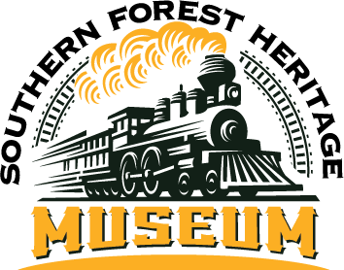
SFHM FALL FESTIVAL 2024
OCTOBER 18 - 19
Friday 4p -7p
Saturday 10a – 7p

77 Longleaf Road • Long Leaf, LA 71448 • 318-748-8404
director@forestheritagemuseum.org OR linda@thegwmc.com

RETAIL BOOTH RESERVATION - $25 nonrefundable due by October 10th

BUSINESS/BOOTH NAME:________________________________________________________________
CONTACT NAME:_______________________________________________________________________
ADDRESS:_____________________________________________________________________________
_____________________________________________________________________________________
PHONE:___________________________EMAIL:______________________________________________
LIST MERCHANDISE BEING SOLD:________________________________________________________________________________
_____________________________________________________________________________________
_____________________________________________________________________________________
ELECTRICITY: NONE NUMBER OF BOOTH SPACES (10’X10’ EACH) ____________________
AMOUNT OF PAYMENT ENCLOSED:________________________________________________________
I, the undersigned, do hereby acknowledge that neither the Southern Forestry Heritage Museum Fall Festival, its Board of Directors, the Rapides Parish Sheriff’s Office nor the village of Long Leaf is responsible for losses or damages to my merchandise or for personal injury to myself or any assigned workers during this festival.
_____________________________________________________ _______________________
NAME DATE

The SFHM Fall Festival is operated by and proceeds benefit the museum and its site, a nonprofit organization.

